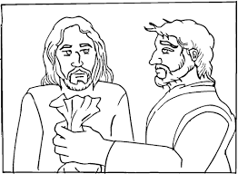 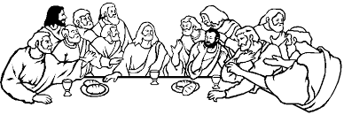

As Jesus dies the sky turns black. Miss a turn.

One of the other men crucified with Jesus repents. Move on 3.

.

Jesus is buried in a tomb covered by a large stone. Go back 3 spaces.

Judas betrays Jesus. Miss a turn.

FINISH

Jesus has supper with his friends. Move on 2 spaces

Jesus meets with his disciples. Roll again.

3 days later Jesus is alive and leaves the tomb. Go to the finish.

Simon of Cyrene carries the cross for Jesus. Move on 1 space.

Pontius Pilate asks the crowd what should happen to Jesus. Go back 4.

Jesus is arrested in the garden of Gethsemane. Go back to the start.

START



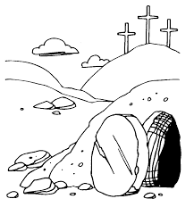

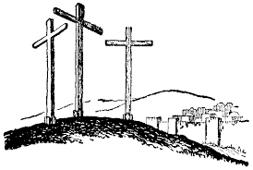

Jesus is put on a cross. Go back to the start.